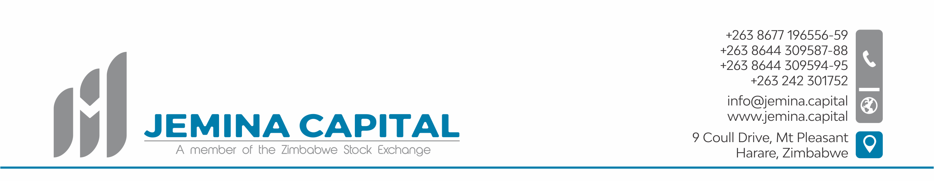

**Meeting of the Shareholders of Jemina Capital (Private) Limited, held at 16 Arundel Road, Alexandra Park, Harare, dated 26th January 2021, at 0900Hours.**

Present: Mr. Francis Kaondera (FK),

Mr. Mashoko Tserere Dzimiri (MTD),

Ms. Immaculate Chibango (IC).

There being a quorum FK, in his capacity as the Chairman of the Meeting, declared the Meeting in session, welcomed everyone present and made formal introductions of Members. He went on to state the purpose of the Meeting, which was to:

1. Formally introduce and ratify the formation of Jemina Capital (Private) Limited, a Company formed for the purpose of conducting the business of a stockbroking firm in Zimbabwe.
2. To ratify the appointment of Board Members and other key Officers of the Company, and to elect a Board Chairman.
3. To approve the Share Capital of the Company made up of 2,000 ordinary shares. Having approved the share capital: to authorize the Directors of the Company to deal with the authorized share capital of the Company in the following manner, to the Shareholders of the Company*.* The Shares shall be issued in terms of the pre-emptive rights available to each of the founding shareholders as follows:
   1. Francis Kaondera 65%
   2. Immaculate Chibango 20%
   3. Mashoko Tserere Dzimiri 15%
   4. **Total 100%**

1. To authorize the Board of Directors to act in such a manner as is deemed necessary to ensure that the Company is licensed by the various Regulatory Authorities, and that the Company is set up in such a manner as to be declared fit to operate as a Stockbroking Firm, and upon attainment of such a status: commence trading operations accordingly.

***FK proposed the adoption of the agenda and MTD seconded the motion***. The Meeting’s Agenda was thus unanimously adopted.

FK notified the meeting that Jemina Capital (Private) Limited was registered as a Company on the 21st January 2021 and the following had been appointed as Directors to the Company

* Francis Kaondera: Non-Executive Chairman
* Mashoko Tserere Dzimiri: Managing Director
* Lloyd Mupfurutsa: Executive Director
* Menard Dzikiti: Company Secretary

***IC proposed the appointment of the Directors and Officers as stated above***, and **MTD** seconded. The motion was passed without any objection.

***MTD proposed that Mr. Francis Kaondera be appointed as Board Chairman of Jemina Capital (Private) Limited***. **IC** seconded the motion and it was carried without objection. ***Mr. Kaondera was duly elected as Chairman of the Board of Jemina Capital (Private) Limited***.

***FK proposed the ratification of the share capital of the Company fixed at 2,000 shares***. **IC** seconded the motion, and it was passed without objection.

***FK Proposed that the Directors be authorized to issue 100 ordinary shares capital of the Company by initiating a capital call on the Shareholders of the Company in proportion to their existing pre-emptive rights in the Company***. The Call is to facilitate capitalization of the Company in order to facilitate licensing and commenced of business activity. MTD seconded the motion and it was passed without objection.

It was further proposed that the Directors of the Company be authorized to initiate processes to get the Company licensed by SECZ, the ZSE and FINSEC in order to commence trading in the shortest possible time as the Regulators may permit. IC proposed, MTD seconded, and the motion was carried without objection.

There being no further business that Chairman closed the Shareholders’ Meeting at 11:15 hours.

Signed (Chairman) …………………………………………

Secretary ………………………………………………………….

Date………………………………………………………………..

